Preparation of 2-page Manuscript for

IEEE AMPHE 2020
First A. Author, Second B. Author, Jr., and Third C. Author, Member, IEEE
Abstract—These instructions give you guidelines for preparing papers for papers for IEEE TRANSACTIONS and CONFERENCES. Use this document as a template if you are using Microsoft Word 6.0 or later. Otherwise, use this document as an instruction set. The electronic file of your paper will be formatted further at IEEE. Define all symbols used in the abstract. Do not cite references in the abstract. Do not delete the blank line immediately above the abstract; it sets the footnote at the bottom of this column. papers for IEEE TRANSACTIONS and CONFERENCES. Use this document as a template if you are using Microsoft Word 6.0 or later. Otherwise, use this document as an instruction set. The electronic file of your paper will be formatted further at IEEE. Define all symbols used in the abstract. Do not cite references in the abstract. Do not delete the blank line immediately above the abstract; it sets the footnote at the bottom of this column.

Index Terms—About four key words or phrases in alphabetical order, separated by commas. For a list of suggested keywords, send a blank e-mail to keywords@ieee.org or visit http://www.ieee.org/organizations/pubs/ani_prod/keywrd98.txt

INTRODUCTION
T
HIS document is a template for Microsoft Word versions 6.0 or later. If you are reading a paper or PDF version of this document, please download the electronic file,
TRANS-JOUR.DOC, from the IEEE Web site at http://www.ieee.org/web/publications/authors/transjnl/index.html so you can use it to prepare your manuscript. If you would prefer to use LATEX, download IEEE’s LATEX style and sample files from the same Web page. Use these LATEX files for formatting, but please follow the instructions in TRANS-JOUR.DOC or TRANS-JOUR.PDF.
When you open TRANS-JOUR.DOC, select “Page Layout” from the “View” menu in the menu bar (View | Page Layout),
which allows you to see the footnotes. Then, type over sections of TRANS-JOUR.DOC or cut and paste from another document and use markup styles. The pull-down style menu is at the left of the Formatting Toolbar at the top of your Word window (for example, the style at this point in the document is “Text”). Highlight a section that you want to designate with a certain style, then select the appropriate name on the style menu. The style will adjust your fonts and line spacing. Do not change the font sizes or line spacing to squeeze more text into a limited number of pages. Use italics for emphasis; do not underline.
To insert images in Word, position the cursor at the insertion point and either use Insert | Picture | From File or copy the image to the Windows clipboard and then Edit | Paste Special | Picture (with “float over text” unchecked).
IEEE will do the final formatting of your paper.

Procedure for Paper Submission

Review Stage
Please go to http://mc.manuscriptcentral.com/jqe-ieee to submit your manuscript. Biographies are optional during the review stage but should your paper need to be revised, we will need ALL bios submitted with your revised paper. All revised papers should include a copy of the revised paper UNDERLINED to show changes as well as a clean copy without the underlines.

Final Stage
When you submit your final version (after your paper has been accepted), print it in two-column format, including figures and tables. Also, a complete list of contact information for all authors should be included. Include full mailing addresses, telephone numbers, fax numbers, and e-mail addresses. This information will be used to send each author a
complimentary copy of the journal in which the paper appears. In addition, designate one author as the “corresponding author.” This is the author to whom proofs of the paper will be sent. Proofs are sent to the corresponding author only.

Copyright Form
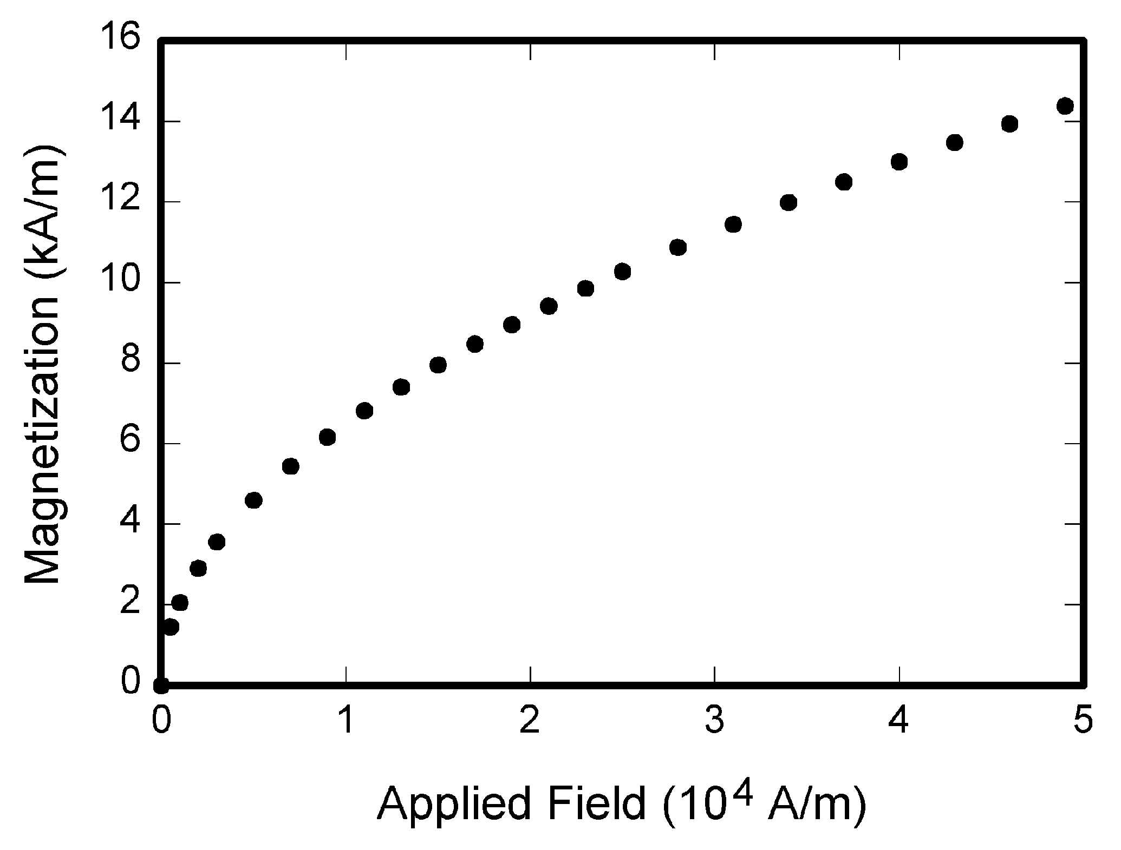
Fig. 1. Magnetization as a function of applied field. Note that “Fig.” is abbreviated. There is a period after the figure number, followed by two spaces. It is good practice to explain the significance of the figure in the caption.

TABLE I
Units for Magnetic Properties
Symbol | Quantity | Conversion from Gaussian and  CGS EMU to SI ª
Φ | magnetic flux | 1 Mx → 10⁻⁸ Wb = 10⁻⁸ V·s
B | magnetic flux density,  magnetic induction | 1 G → 10⁻⁴ T = 10⁻⁴ Wb/m²
H | magnetic field strength | 1 Oe → 10³/(4π) A/m
m | magnetic moment | 1 erg/G = 1 emu  → 10⁻³ A·m² = 10⁻³ J/T
M | magnetization | 1 erg/(G·cm³) = 1 emu/cm³  → 10³ A/m
4πM | magnetization | 1 G → 10³/(4π) A/m
σ | specific magnetization | 1 erg/(G·g) = 1 emu/g → 1 A·m²/kg
j | magnetic dipole  moment | 1 erg/G = 1 emu  → 4π × 10⁻¹⁰ Wb·m
J | magnetic polarization | 1 erg/(G·cm³) = 1 emu/cm³  → 4π × 10⁻⁴ T
χ, κ | susceptibility | 1 → 4π
χ_{ρ} | mass susceptibility | 1 cm³/g → 4π × 10⁻³ m³/kg
μ | permeability | 1 → 4π × 10⁻⁷ H/m  = 4π × 10⁻⁷ Wb/(A·m)
μ_{r} | relative permeability | μ → μ_{r}
w, W | energy density | 1 erg/cm³ → 10⁻¹ J/m³
N, D | demagnetizing factor | 1 → 1/(4π)
Vertical lines are optional in tables. Statements that serve as captions for the entire table do not need footnote letters.
ªGaussian units are the same as cgs emu for magnetostatics; Mx = maxwell, G = gauss, Oe = oersted; Wb = weber, V = volt, s = second, T = tesla, m = meter, A = ampere, J = joule, kg = kilogram, H = henry.

An IEEE copyright form should accompany your final submission. You can get a .pdf, .html, or .doc version at http://www.ieee.org/copyright. Authors are responsible for obtaining any security clearances.

Conclusion
A conclusion section is not required. Although a conclusion may review the main points of the paper, do not replicate the abstract as the conclusion. A conclusion might elaborate on the importance of the work or suggest applications and extensions.
Appendixes, if needed, appear before the acknowledgment.

Acknowledgment
The preferred spelling of the word “acknowledgment” in American English is without an “e” after the “g.” Use the singular heading even if you have many acknowledgments. Avoid expressions such as “One of us (S.B.A.) would like to thank ... .” Instead, write “F. A. Author thanks ... .” Sponsor and financial support acknowledgments are placed in the unnumbered footnote on the first page, not here.

References
- G. O. Young, “Synthetic structure of industrial plastics (Book style with paper title and editor),” in Plastics, 2nd ed. vol. 3, J. Peters, Ed. New York: McGraw-Hill, 1964, pp. 15–64.
- W.-K. Chen, Linear Networks and Systems (Book style). Belmont, CA: Wadsworth, 1993, pp. 123–135.
- H. Poor, An Introduction to Signal Detection and Estimation. New York: Springer-Verlag, 1985, ch. 4.
- B. Smith, “An approach to graphs of linear forms (Unpublished work style),” unpublished.
- E. H. Miller, “A note on reflector arrays (Periodical style—Accepted for publication),” IEEE Trans. Antennas Propagat., to be published.
- J. Wang, “Fundamentals of erbium-doped fiber amplifiers arrays (Periodical style—Submitted for publication),” IEEE J. Quantum Electron., submitted for publication.
- C. J. Kaufman, Rocky Mountain Research Lab., Boulder, CO, private communication, May 1995.
- Y. Yorozu, M. Hirano, K. Oka, and Y. Tagawa, “Electron spectroscopy studies on magneto-optical media and plastic substrate interfaces (Translation Journals style),” IEEE Transl. J. Magn.Jpn., vol. 2, Aug. 1987, pp. 740–741 [Dig. 9th Annu. Conf. Magnetics Japan, 1982, p. 301].
- M. Young, The Techincal Writers Handbook. Mill Valley, CA: University Science, 1989.
- J. U. Duncombe, “Infrared navigation—Part I: An assessment of feasibility (Periodical style),” IEEE Trans. Electron Devices, vol. ED-11, pp. 34–39, Jan. 1959.
- S. Chen, B. Mulgrew, and P. M. Grant, “A clustering technique for digital communications channel equalization using radial basis function networks,” IEEE Trans. Neural Networks, vol. 4, pp. 570–578, Jul. 1993.
- R. W. Lucky, “Automatic equalization for digital communication,” Bell Syst. Tech. J., vol. 44, no. 4, pp. 547–588, Apr. 1965.
- S. P. Bingulac, “On the compatibility of adaptive controllers (Published Conference Proceedings style),” in Proc. 4th Annu. Allerton Conf. Circuits and Systems Theory, New York, 1994, pp. 8–16.
- G. R. Faulhaber, “Design of service systems with priority reservation,” in Conf. Rec. 1995 IEEE Int. Conf. Communications, pp. 3–8.
- W. D. Doyle, “Magnetization reversal in films with biaxial anisotropy,” in 1987 Proc. INTERMAG Conf., pp. 2.2-1–2.2-6.
- G. W. Juette and L. E. Zeffanella, “Radio noise currents n short sections on bundle conductors (Presented Conference Paper style),” presented at the IEEE Summer power Meeting, Dallas, TX, Jun. 22–27, 1990, Paper 90 SM 690-0 PWRS.
- J. G. Kreifeldt, “An analysis of surface-detected EMG as an amplitude-modulated noise,” presented at the 1989 Int. Conf. Medicine and Biological Engineering, Chicago, IL.
- J. Williams, “Narrow-band analyzer (Thesis or Dissertation style),” Ph.D. dissertation, Dept. Elect. Eng., Harvard Univ., Cambridge, MA, 1993.
- N. Kawasaki, “Parametric study of thermal and chemical nonequilibrium nozzle flow,” M.S. thesis, Dept. Electron. Eng., Osaka Univ., Osaka, Japan, 1993.

ALL BIOS ARE REQUIRED

First A. Author (M’76–SM’81–F’87) and the other authors may include biographies at the end of regular papers. Biographies are often not included in conference-related papers. This author became a Member (M) of IEEE in 1976, a Senior Member (SM) in 1981, and a Fellow (F) in 1987. The first paragraph may contain a place and/or date of birth (list place, then date). Next, the author’s educational background is listed. The degrees should be listed with type of degree in what field, which institution, city, state, and country, and year degree was earned. The author’s major field of study should be lower-cased.
The second paragraph uses the pronoun of the person (he or she) and not the author’s last name. It lists military and work experience, including summer and fellowship jobs. Job titles are capitalized. The current job must have a location; previous positions may be listed without one. Information concerning previous publications may be included. Try not to list more than three books or published articles. The format for listing publishers of a book within the biography is: title of book (city, state: publisher name, year) similar to a reference. Current and previous research interests end the paragraph.
The third paragraph begins with the author’s title and last name (e.g., Dr. Smith, Prof. Jones, Mr. Kajor, Ms. Hunter). List any memberships in professional societies other than the IEEE. Finally, list any awards and work for IEEE committees and publications. If a photograph is provided, the biography will be indented around it. The photograph is placed at the top left of the biography. Personal hobbies will be deleted from the biography.

Manuscript received October 9, 2001. (Write the date on which you submitted your paper for review.) This work was supported in part by the U.S. Department of Commerce under Grant BS123456 (sponsor and financial support acknowledgment goes here). Paper titles should be written in uppercase and lowercase letters, not all uppercase. Avoid writing long formulas with subscripts in the title; short formulas that identify the elements are fine (e.g., "Nd–Fe–B"). Do not write “(Invited)” in the title. Full names of authors are preferred in the author field, but are not required. Put a space between authors’ initials. F. A. Author is with the National Institute of Standards and Technology, Boulder, CO 80305 USA (corresponding author to provide phone: 303-555-5555; fax: 303-555-5555; e-mail: author@ boulder.nist.gov). S. B. Author, Jr., was with Rice University, Houston, TX 77005 USA. He is now with the Department of Physics, Colorado State University, Fort Collins, CO 80523 USA (e-mail: author@lamar.colostate.edu). T. C. Author is with the Electrical Engineering Department, University of Colorado, Boulder, CO 80309 USA, on leave from the National Research Institute for Metals, Tsukuba, Japan (e-mail: author@nrim.go.jp).

