MATHEMATICS

PAPERMAKER10

LEVEL-I

- If A = P ({3, 4}) where P denotes the power set, then which one is correct?
(a) {3, 4} $⊂$A
(b) 3$∈$A
(c) $ϕ$ $∈$A
(d) {3, 4} $∈$ A
L1Difficulty1
Qtag Mathematics
Qcreator Pagemaker10

- If the cardinality of a set A is 5 and that of a set B is 4, then what is the cardinality of the set A$∆$B?
(a) 1
(b) 5
(c) 8
(d) Cannot be determined
L1Difficulty1
Qtag Mathematics
Qcreator Pagemaker10

- If A, B, C are three non collinear points then what is AB $∩$ AC equal to?
(a) Null set
(b) {A}
(c) {A, B, C}
(d) {B, C}
L1Difficulty1
Qtag Mathematics
Qcreator Pagemaker10

- The shaded region is
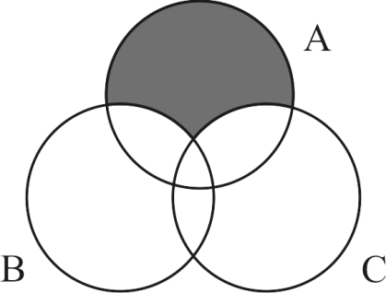
(a) A $∩$ (B$∪$C)
(b) A $∪$ ($B∩C$)
(c) A$∪$ (B$∩$C)
(d) A – (B$∪$C)
L1Difficulty1
Qtag Mathematics
Qcreator Pagemaker10

- P and Q is subset of x, then {P$∩$ (X – Q)} $∪$Q equal to
(a) P$∪$Q
(b) P$∩$Q
(c) P
(d) Q
L1Difficulty1
Qtag Mathematics
Qcreator Pagemaker10

- In a school of 600 students, every student reads 5 newspaper and every newspaper read by 120 students, the number of students is?
(a) atleast 30
(b) almost 20
(c) exactly 25
(d) atleast 50
L1Difficulty1
Qtag Mathematics
Qcreator Pagemaker10

- If P = {4x + 2 | X $∈$ N} and Q = {|3x|, X is N} then P$∩$Q is
(a) {12x² + 6x|, X $∈$ N
(b) {24x – 12|, X $∈$ N
(c) {60x + 30| X $∈$ N
(d) {12x – 6|, X $∈$N
L1Difficulty1
Qtag Mathematics
Qcreator Pagemaker10

- N $∈$ denote Natural No. P = {x²; X $∈$ N} Q = {x³: X $∈$ N} which one is correct?
(a) P $∪$ Q = N
(b) (P$∪$Q) is infinite set
(c) P $∩$ Q finite set
(d) P $∩$ Q proper subset {a⁶ : a $∈$ N}
L1Difficulty1
Qtag Mathematics
Qcreator Pagemaker10

- If P = {y : y² – 3y + 2 = 0} and $Q$ = {y : y² + 2y – 8 = 0} P – $Q$ is
(a) {1, 2}
(b) {2}
(c) {1}
(d) {4, 3}
L1Difficulty1
Qtag Mathematics
Qcreator Pagemaker10

- Let P = {y : y $∈$ R, |y| < 1}, Q = {y : y $∈$ R, |y – 1| $≥$ 1} and P$∪$Q = R – D the set D is
(a) {y : 1 < y $≤$ 2}
(b) {y : 1 $≤$ y < 2}
(c) {y : 1 $≤$ y $≤$ 2}
(d) none
L1Difficulty1
Qtag Mathematics
Qcreator Pagemaker10

Solutions

S1. Ans. (d)
Sol.
Let B = {3, 4}
A = P(B) = {$ϕ$, {3} {4}, {3, 4} {3, 4} $∈$A.

S2. Ans. (d)
Sol.
We do not know about the set A and B about their element, so we cannot find the cardinality be found.

S3. Ans. (b)
Sol.
A, B, C are non-collinear points AB $∩$ AC = {A}
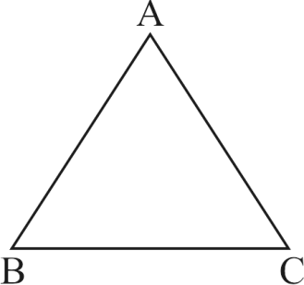

S4. Ans. (d)
Sol.
A – (B$∪$C)
(A – B) $∩$ (A – C)

S5. Ans. (a)
Sol.
(P $∩$ X) $∪$ (P $∩$ Q)
P $∪$ Q

S6. Ans. (c)
Sol.
Let No. of Newspaper x.
120 × x = 600 × 5
x = 25

S7. Ans. (d)
Sol.
P = {4x + 2, X $∈$ N
= {6, 10, 14, 18, 22, 26, 30 ...............}
Q = {3x| X $∈$ N
= {3, 6, 9, 12, 15, 18, 21, 24, 27, 30 ................}
P $∩$ Q = {6, 18, 30 ................}
P $∩$Q = {6 + (n – 1)12 | X $∈$ N
= {12n – 6 | X $∈$ N

S8. Ans. (d)
Sol.
P = {x²; X $∈$ N}
Q = {x³ : X $∈$ N}
So = A $∩$ B be proper subset of {a⁶ : a $∈$ N}

S9. Ans. (b)
Sol.
P = {1, 2} $Q$ = {–4, 2}
P – $Q$ = {2}

S10. Ans. (b)
Sol.
P = {y : y $∈$ R, –1 < y < 1}
Q = {y : y $∈$ R, y – 1 $≤$ –1} or y – 1 $≥$ 1
{y : y $∈$ R, y $≤$ 0 or y $≥$ 2}
P$∪$Q = {y : y $∈$ R, y < 1 or y > 2} = R – D
D = {y : y $∈$ R, 1 $≤$ y $≤$ 2}

LEVEL-II

Q1. x = {(x, y) : x² + y² = 25} and B = {x, y : x² + 9y² = 144} then A $∩$ B
(a) one point
(b) three points
(c) two points
(d) four points
L3Difficulty3
Qtag Mathematics
Qcreator Pagemaker10

Q2. If two sets A and B having 3 and 6 elements respectively, then which of the following is correct
(i) minimum no. of elements (A $∪$ B) = 6
(ii) the maximum no. of elements (A $∩$ B) = 3
(a) only (i)
(b) only (ii)
(c) Both (i) and (ii)
(d) Neither (i) nor (ii)
L3Difficulty3
Qtag Mathematics
Qcreator Pagemaker10

Q3. Consider the following statements
(i) All poets (P) are Learned (L)
(ii) All Learned (L) are Happy (H)
Which one of the following venn diagram correctly represent both the above statements taken together?
(a) | 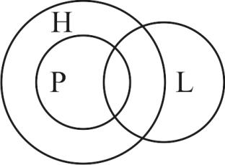
(d) | 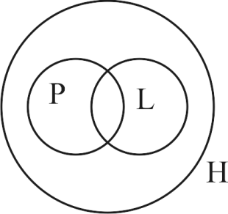
(c) | 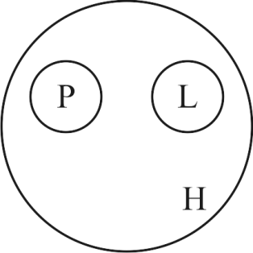
(d) | 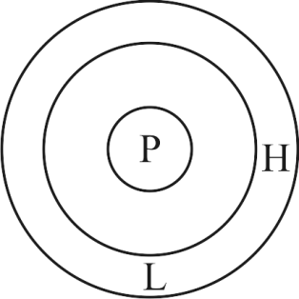
L3Difficulty3
Qtag Mathematics
Qcreator Pagemaker10

Q4. If A$∪$B = A$∪$C and (A$∩$B) = (A$∩$C) which stays valid if and only
(i) B = C (ii) A = B = C (iii) A = C
which is correct
(a) only I
(b) only II
(c) Both I and II
(d) only III
L3Difficulty3
Qtag Mathematics
Qcreator Pagemaker10

Q5. Total no. of element in the power set of A containing 15 elements is
(a) 2¹⁵
(b) 15²
(c) 2^{15–1}
(d) 2¹⁵ – 1
L3Difficulty3
Qtag Mathematics
Qcreator Pagemaker10

Q6. What is the no. of proper subset of a given finite set with n – element
(a) 2n – 1
(b) 2n – 2
(c) 2^{n} – 1
(d) 2^{n} – 2
L3Difficulty3
Qtag Mathematics
Qcreator Pagemaker10

Q7. n($∪$) = 700 n(A) = 200 n(B) = 300 n(A$∩$B) = 100 then n(A^{c} $∩$ B^{c}) is equal to
(a) 400
(b) 600
(c) 300
(d) none of these
L3Difficulty3
Qtag Mathematics
Qcreator Pagemaker10

Q8. | 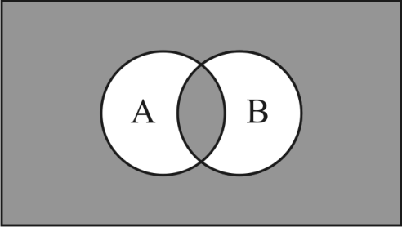
n(E) = 42, n(A) = 15, n(B) = 12
n(A$∪$B) = 22 then the area represent by shaded portion is
(a) 25
(b) 27
(c) 32
(d) 37
L3Difficulty3
Qtag Mathematics
Qcreator Pagemaker10

Q9. If A and B are any two sets, then what is the value of A $∩$ (A$∪$B)?
(a) A^{c}
(b) B^{c}
(c) B
(d) A
L3Difficulty3
Qtag Mathematics
Qcreator Pagemaker10

Q10. Let A = {n : n is a square of natural no. and x is less than 100} and B is a set of even natural no. What is the cardinality of A$∩$B?
(a) 4
(b) 5
(c) 9
(d) None
L3Difficulty3
Qtag Mathematics
Qcreator Pagemaker10

Solutions

S1. Ans. (d)
Sol.
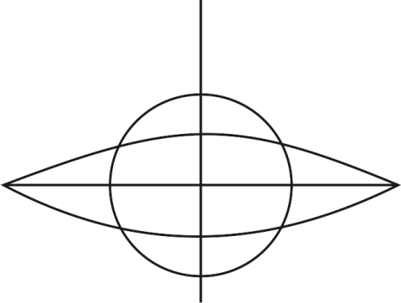
x² + y² = 25 (circle)
x² + 9y² = 144 (ellipse)
four points.

S2. Ans. (c)
Sol.
n(A$∪$B) = n(A) + n(B) – n(A$∩$B)
= 3 + 6 – n (A$∩$B)
= 9 – n (A$∩$B)
n(A$∩$B) = 3 elements (maximum)
= 9 – 3 = 6

S3. Ans. (d)
Sol.
Poets, learned and Happy three categories, venn diagram will be
Statement-I:
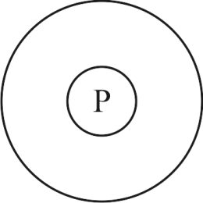
P $∩$ L
Statement-II:
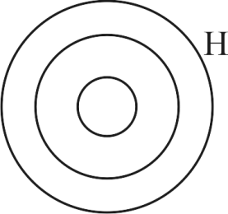
L $∩$ H
P $∩$ L $∩$ H

S4. Ans. (a)
B = B$∪$ (A$∩$C)
= (B$∪$A) $∩$(B$∪$C)
= (A$∩$B) $∪$C
= (A$∩$C) $∪$C = C

S5. Ans. (d)
Sol.
If A has n – elements then its power set contain 2^{n} element
total no. of element
A = 2^{n} – 1

S6. Ans. (c)
Sol.
No. of subset is 2^{n}
proper subset is 2^{n} – 1

S7. Ans. (c)
Sol.
n(A^{c} $∩$ B^{c}) = n(A$∪$B)^{c}
= n$∪$ – n(A$∪$B)
n(A^{c} $∩$ B^{c}) = 300

S8. Ans. (a)
Sol.
Shaded Region
= n(E) – n(A$∪$B) + n(A$∩$B)
= n(E) – n(A$∪$B) + n(A) +n(B) – n(A$∪$B)
= 42 – 22 + 15 + 12 – 22
= 25

S9. Ans. (d)
Sol.
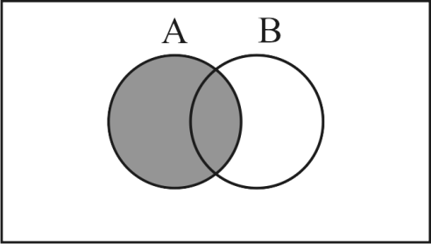

S10. Ans. (a)
Sol.
A = {1, 4, 9, 16, 25, ....... 81}
B = {2, 4, 6, ...................}
A$∩$B = {4, 16, 36, 64}
No. of element n(A$∩$B) = 4

LEVEL-III

Q1. $∪$ = {x $∈$ N, : 1 $≤$ x $≤$ 10} be the universal set N being the set of natural number if A = {1, 2, 3, 4} and B = {2, 3, 6, 10} (A – B)^{c}
(a) {6, 10}
(b) {1, 4}
(c) {2, 3, 5, 6, 7, 8, 9, 10}
(d) {5, 6, 7, 8, 9, 10}
L5Difficulty5
Qtag Mathematics
Qcreator Pagemaker10

Q2. Which of the following is null set?
(a) {0}
(b) $\left\{\{ \}\right\}$
(c) $\{\{\{ \}\}\}$
(d) {x | x² + 1 = 0, x $∈$ R}
L5Difficulty5
Qtag Mathematics
Qcreator Pagemaker10

Q3. A is subset A+B, then which one of the following is correct?
(a) A^{C} $⊂$ B^{C}
(b) B^{C} $⊂$ A^{C}
(c) A^{C} = B^{C}
(d) A $⊂$ A$∩$B
L5Difficulty5
Qtag Mathematics
Qcreator Pagemaker10

Q4. A = {1, 3, 5, 7} No. of element is P(A)?
(a) 8
(b) 15
(c) 16
(d) 17
L5Difficulty5
Qtag Mathematics
Qcreator Pagemaker10

Q5. (i) A$∪$ (B$∩$C) = (A$∩$B) $∪$ (A$∩$C)
(ii) A$∩$ (B$∪$C) = (A$∪$B) $∩$ (A$∪$C)
Which of above is correct?
(a) only (i)
(b) only (ii)
(c) (i) and (ii)
(d) neither (i) nor (ii)
L5Difficulty5
Qtag Mathematics
Qcreator Pagemaker10

Q6. Which one of the following is an example of non-empty set?
(a) set of all even prime number
(b) {x : x² = 2, x is rational)
(c) {x : x $∈$ N, x < 8 and x > 12}
(d) {x : x is point common to any two parallel lines
L5Difficulty5
Qtag Mathematics
Qcreator Pagemaker10

Q7. In a class 60 students, 45 students like music, 50 students like dancing, 5 students like neither, then no. of students in the class who like both music and dancing.
(a) 25
(b) 40
(c) 50
(d) 56
L5Difficulty5
Qtag Mathematics
Qcreator Pagemaker10

Q8. Let A = {1, 2, 3, 4, 5, 6, 7, 8, 9, 10} then the no. of subsets of A containing exactly two elements is
(a) 20
(b) 40
(c) 45
(d) 90
L5Difficulty5
Qtag Mathematics
Qcreator Pagemaker10

Q9. If A = {n : n is a multiple of 3}
B = {n : n is a multiple of 12} then which one of the following is a null set?
(a) (A|B) $∪$C
(b) (A|B)|C
(c) (A$∩$B) $∩$C
(d) (A$∩$B)|C
L5Difficulty5
Qtag Mathematics
Qcreator Pagemaker10

Q10. In an examination 100 students 75 passed in English, 60 passed in Mathematics and 45 passed in both English and Mathematics. What is the number of students passed in exactly one of the two subjects?
(a) 45
(b) 60
(c) 75
(d) 90
L5Difficulty5
Qtag Mathematics
Qcreator Pagemaker10

Solutions

S1. Ans. (c)
Sol.
$∪$ = {1, 2, 3, 4, 5, ............... 9, 10}
A = {1, 2, 3, 4} B = {2, 3, 6, 10}
A – B = {1, 4}
(A – B)^{c} = {2, 3, 5, 6, 7, 8, 9, 10}

S2. Ans. (d)
Sol.
n² = –1, n $≠$ R

S3. Ans. (b)
Sol.
$∪$ = {1, 2, 3, 4, 5, 6, 7, 8, 9, 10}
A = {1, 2, 3, 4, 5} B = {1, 2, 3, 4, 5, 6}
A $⊆$ B
A^{C} = {6, 7, 8, 9, 10}
B^{C} = {7, 8, 9, 10}
B^{C} $⊆$ A^{C}
A$∩$B = {1, 2, 3, 4, 5}
A = {A$∩$B}

S4. Ans. (c)
Sol.
2⁴ is No. of element is P(A).

S5. Ans. (d)
Sol.
Neither (i) nor (ii)

S6. Ans. (b)
Sol.
Let S be the set of all even prime no.
S = {2}

S7. Ans. (b)
Sol.
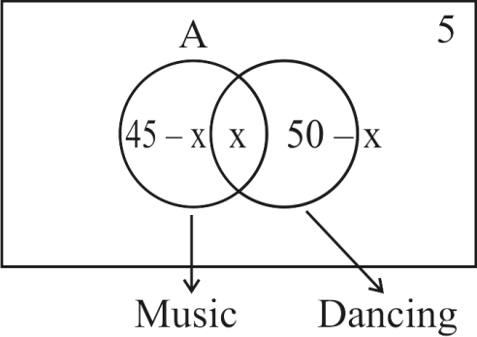
45 – x + x + 50 – x + 5 = 60
x = 40

S8. Ans. (c)
Sol.
Required no. of subset of A exactly two elements = 10
C₂ = $\frac{10 × 9}{2}$ = 45

S9. Ans. (d)
Sol.
A = {3, 6, 9, 12, ............}
B = {12, 24, 36, 48, ...........}
A$∩$B = {12, 24, 36, 48, ...........}
= (A$∩$B)|C = (A$∩$B)C
= null net

S10. Ans. (a)
Sol.
n(E) = 75; n(m) = 60
n(E$∩$M) = 45
= n(E) + n(m) – 2n (E$∩$M)
= 75 + 60 – 90
= 45

